Find my Protest

Data Science

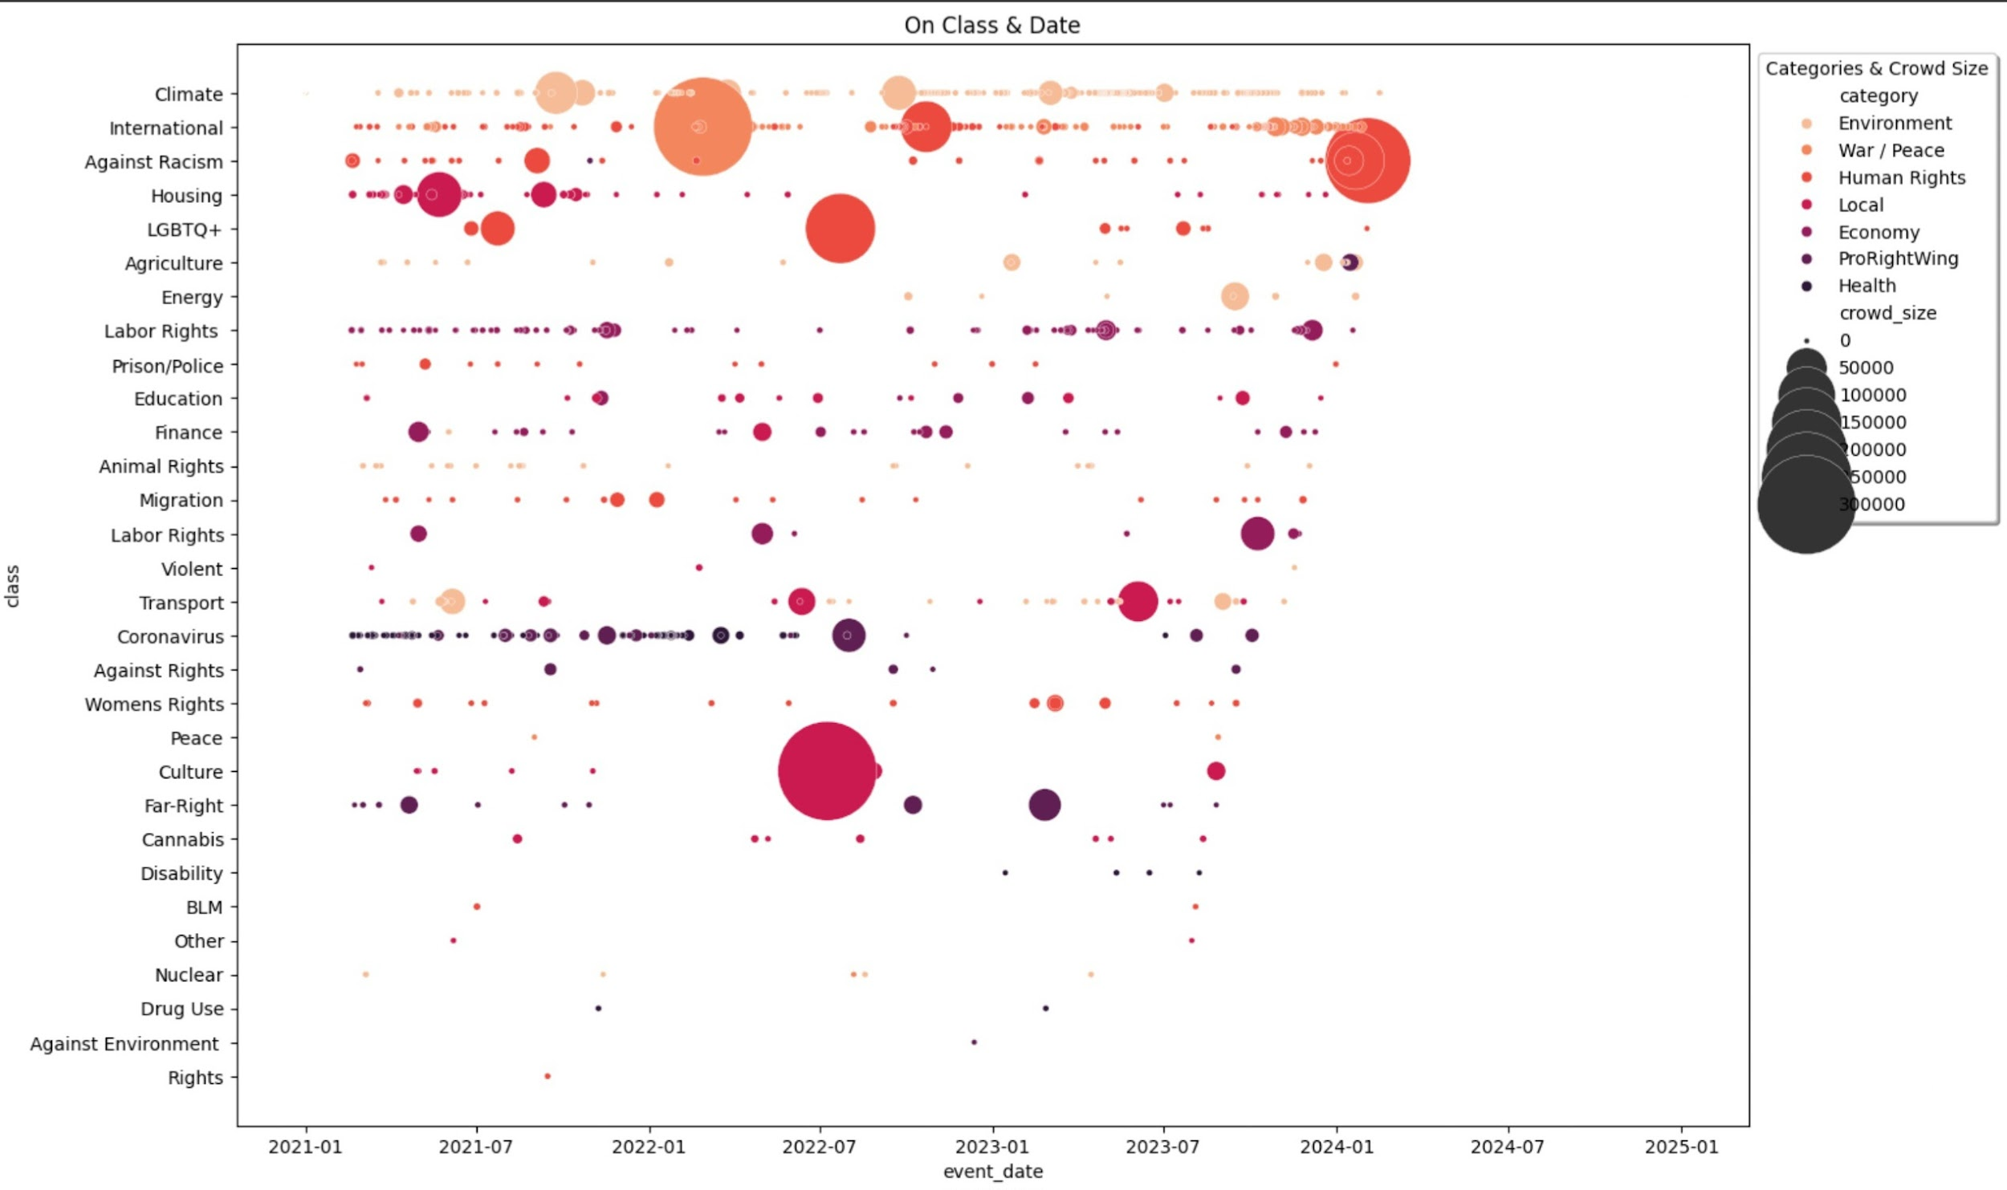

**04.2024**

**TECHLABS BERLIN**

# INTRODUCTION

WE HAVE ANALYZED THE DATA FROM ACLED. (<https://acleddata.com/early-warning/>)

ACLED IS CONNECTING DATA FROM ALL OVER THE WORLD

THE DATA IS FILTERED TO BERLIN *(as you might have guessed)*

AND SPANS FROM 16.02.2021-16.02.2024*(in our data we call this past protests)*

# DATA

1. Categories & Subcategories

| 1 | Economy | 1.1; 1.2 | Finance; Labor Rights; | WE HAVE FILTERED OUT THE PRO-RIGHT-WING COLUMN ON OUR MAIN PAGE  (only left it for analysis).  SINCE WE DON'T WANT TO SUPPORT THIS KIND OF RESEARCH ON OUR WEBSITE.  FURTHER WE HAVE FILTERED OUT  (even in our analysis )  MOB VIOLENCE, SINCE WE WANTED TO CONCENTRATE ON PROTESTS. |
| --- | --- | --- | --- | --- |
| 2 | Environment | 2.1; 2.2; 2.3; 2.4; 2.5 | Agriculture; Animal Rights; Climate; Energy; Nuclear |
| 3 | Health | 3.1; 3.2; 3.3 | Coronavirus; Disability; Drug Use |
| 4 | Human Rights | 4.1; 4.2; 4.3; 4.4; 4.5; 4.6; 4.7 | Against Racism; BLM; LGBTQ+; Migration; Prison/Police; Rights; Women's Rights |
| 5 | Local | 5.1; 5.2; 5.3; 5.4; 5.5; 5.6 | Cannabis; Culture; Education; Housing; Other; Transport; |
| 6 | War / Peace | 6.1; 6.2 | International; Peace |
| 7 | ProRightWing | 7.1; 7.2; 7.3; 7.4 | Against Rights; Far-Right; Violent; Against Environment |

#### 

1. Crowd Size

| 1 | < 50 | WE HAVE FILLED OUT BLANKS WITH THE MEAN OF CROWD SIZE.  FURTHERMORE WE HAVE MATHEMATICALLY CHANGED SOME DATA THAT WAS NOT IN OUR FORMAT (F.E.  ‘about 1.000-6.000’).  WE HAVE THAN CATEGORIZED IT INTO THOSE 11 CATEGORIES. |
| --- | --- | --- |
| 2 | 50 - 100 |
| 3 | 100 - 250 |
| 4 | 250 - 500 |
| 5 | 500 - 1.000 |
| 6 | 1.000 - 2.500 |
| 7 | 2.500 - 5.000 |
| 8 | 5.000 - 10.000 |
| 9 | 10.000 - 50.000 |
| 10 | 50.000 - 100.000 |
| 11 | 100.000 < |

#### 

# 

# 

# 

# 

# RESULTS

1. Boxplots of all Years / By Month & Category

The bigger the crowd size the darker the shade!

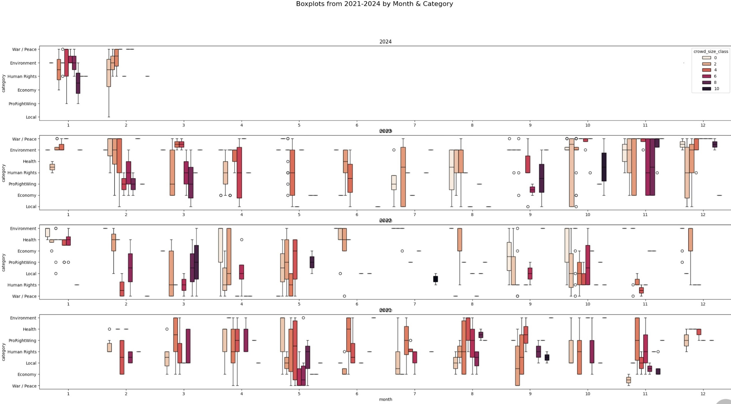

1. Barcharts of all Years / By Date & Crowd Size

x axis = crowd size categorized into 11 classes

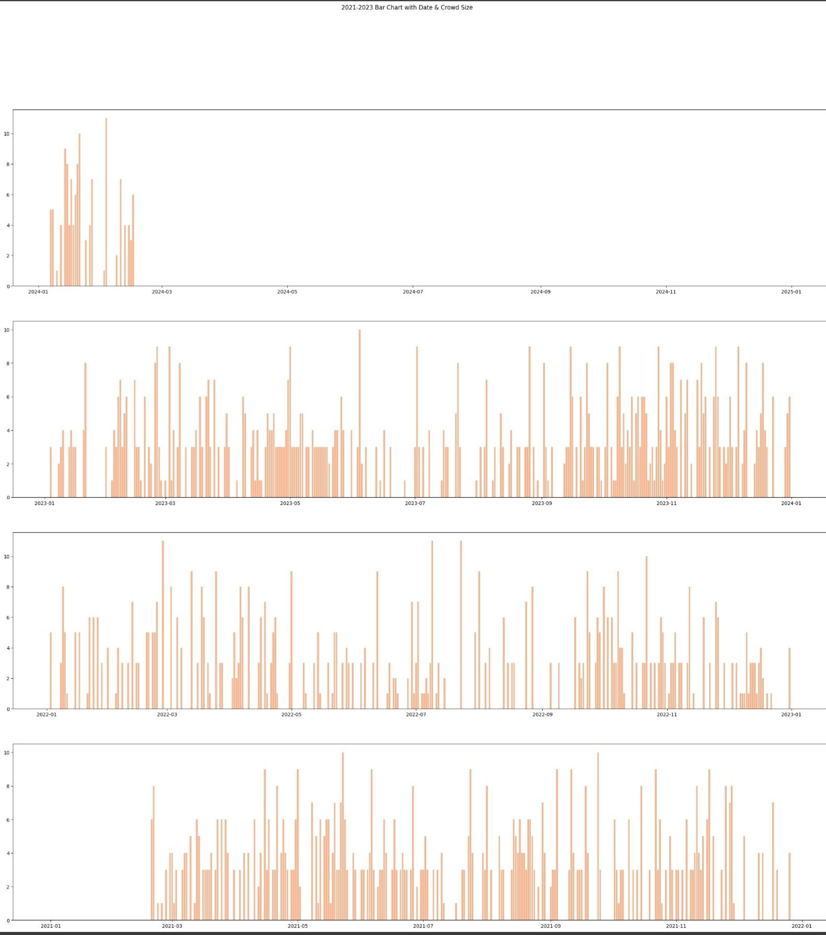

1. Scatterplots in separate Years / By Date & Category

classes are in different shades of red

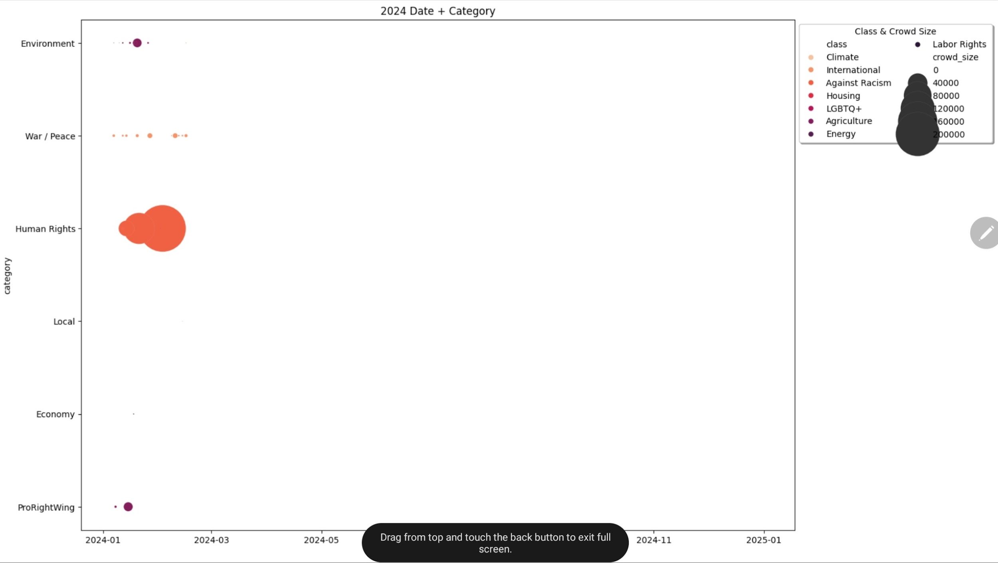

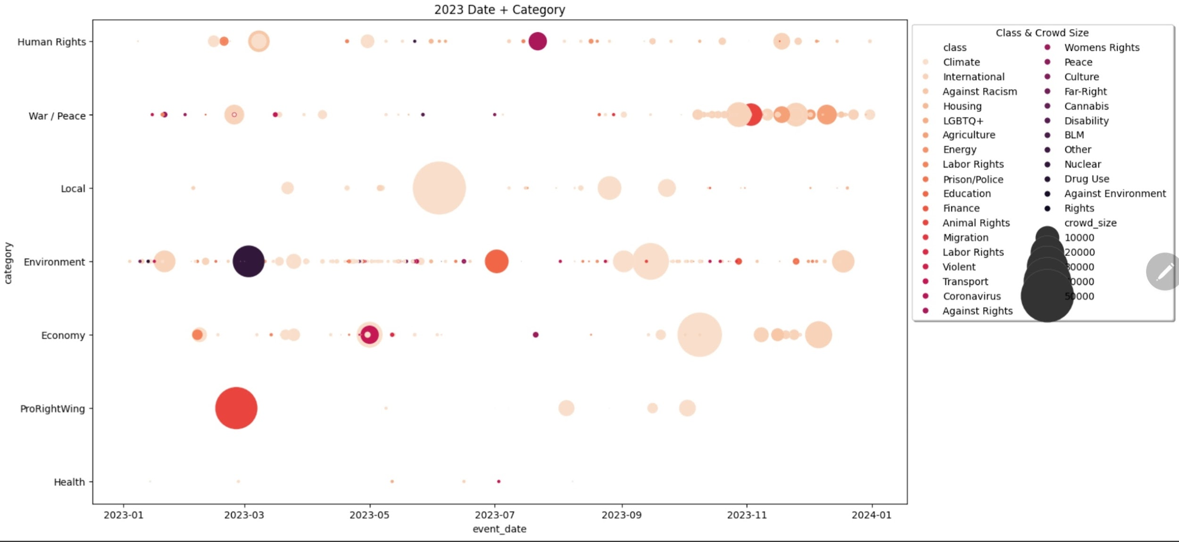

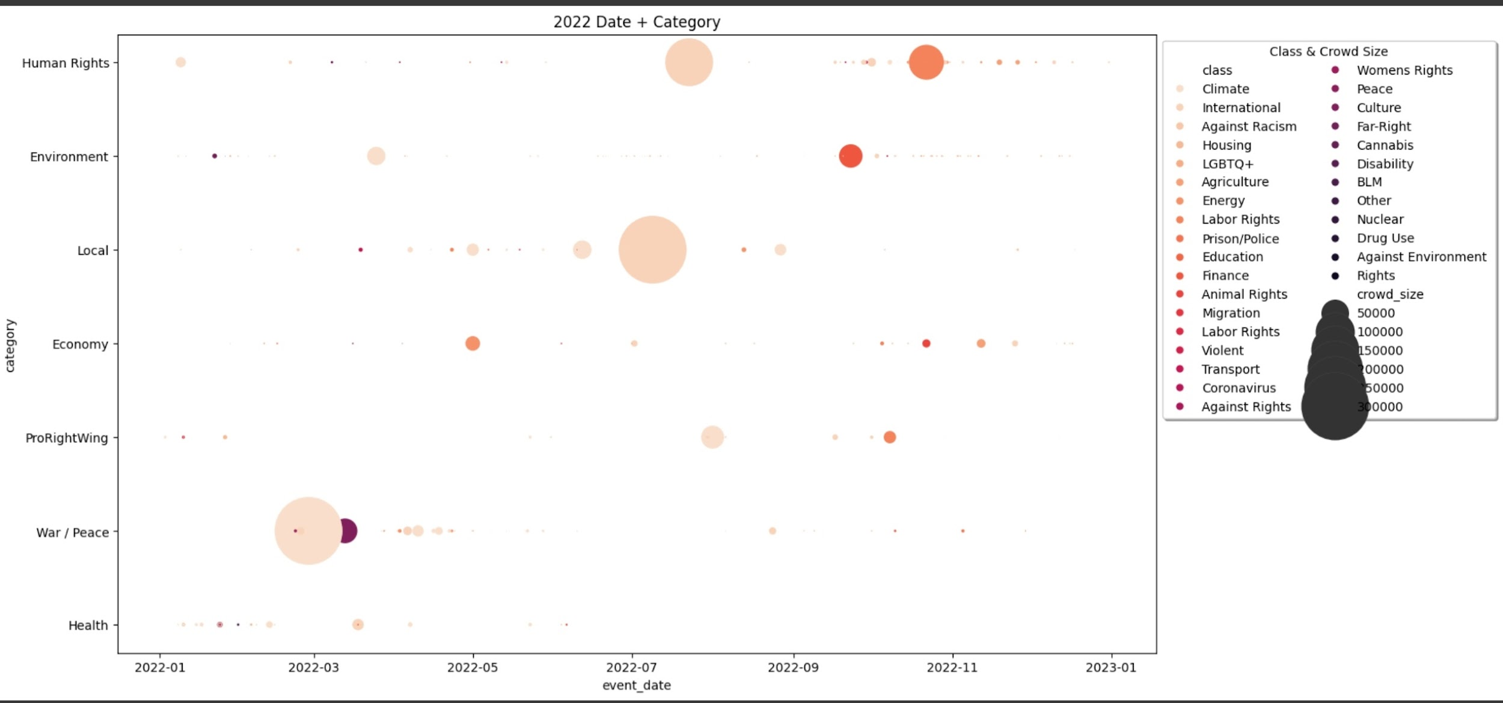

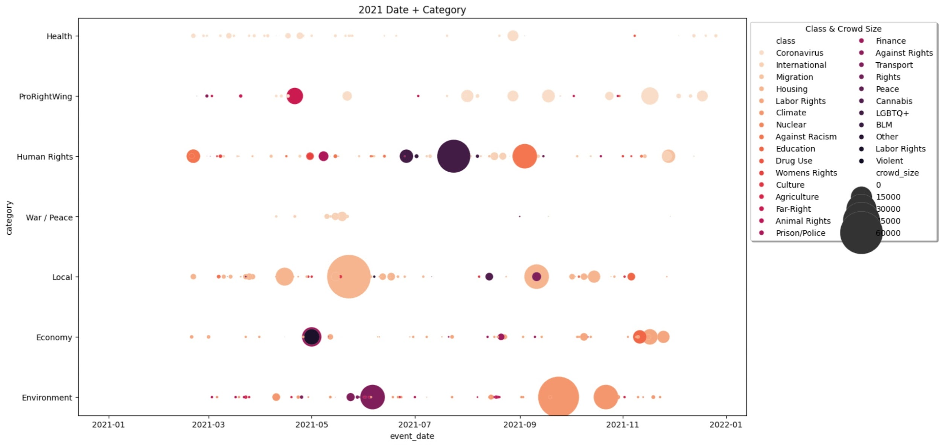

1. Boxplots to Weekdays & District in Categories

You can see on Mondays most of Coronavirus & ProRightwing Protests happen, maybe because I labeled Querdenken as Far-Right?

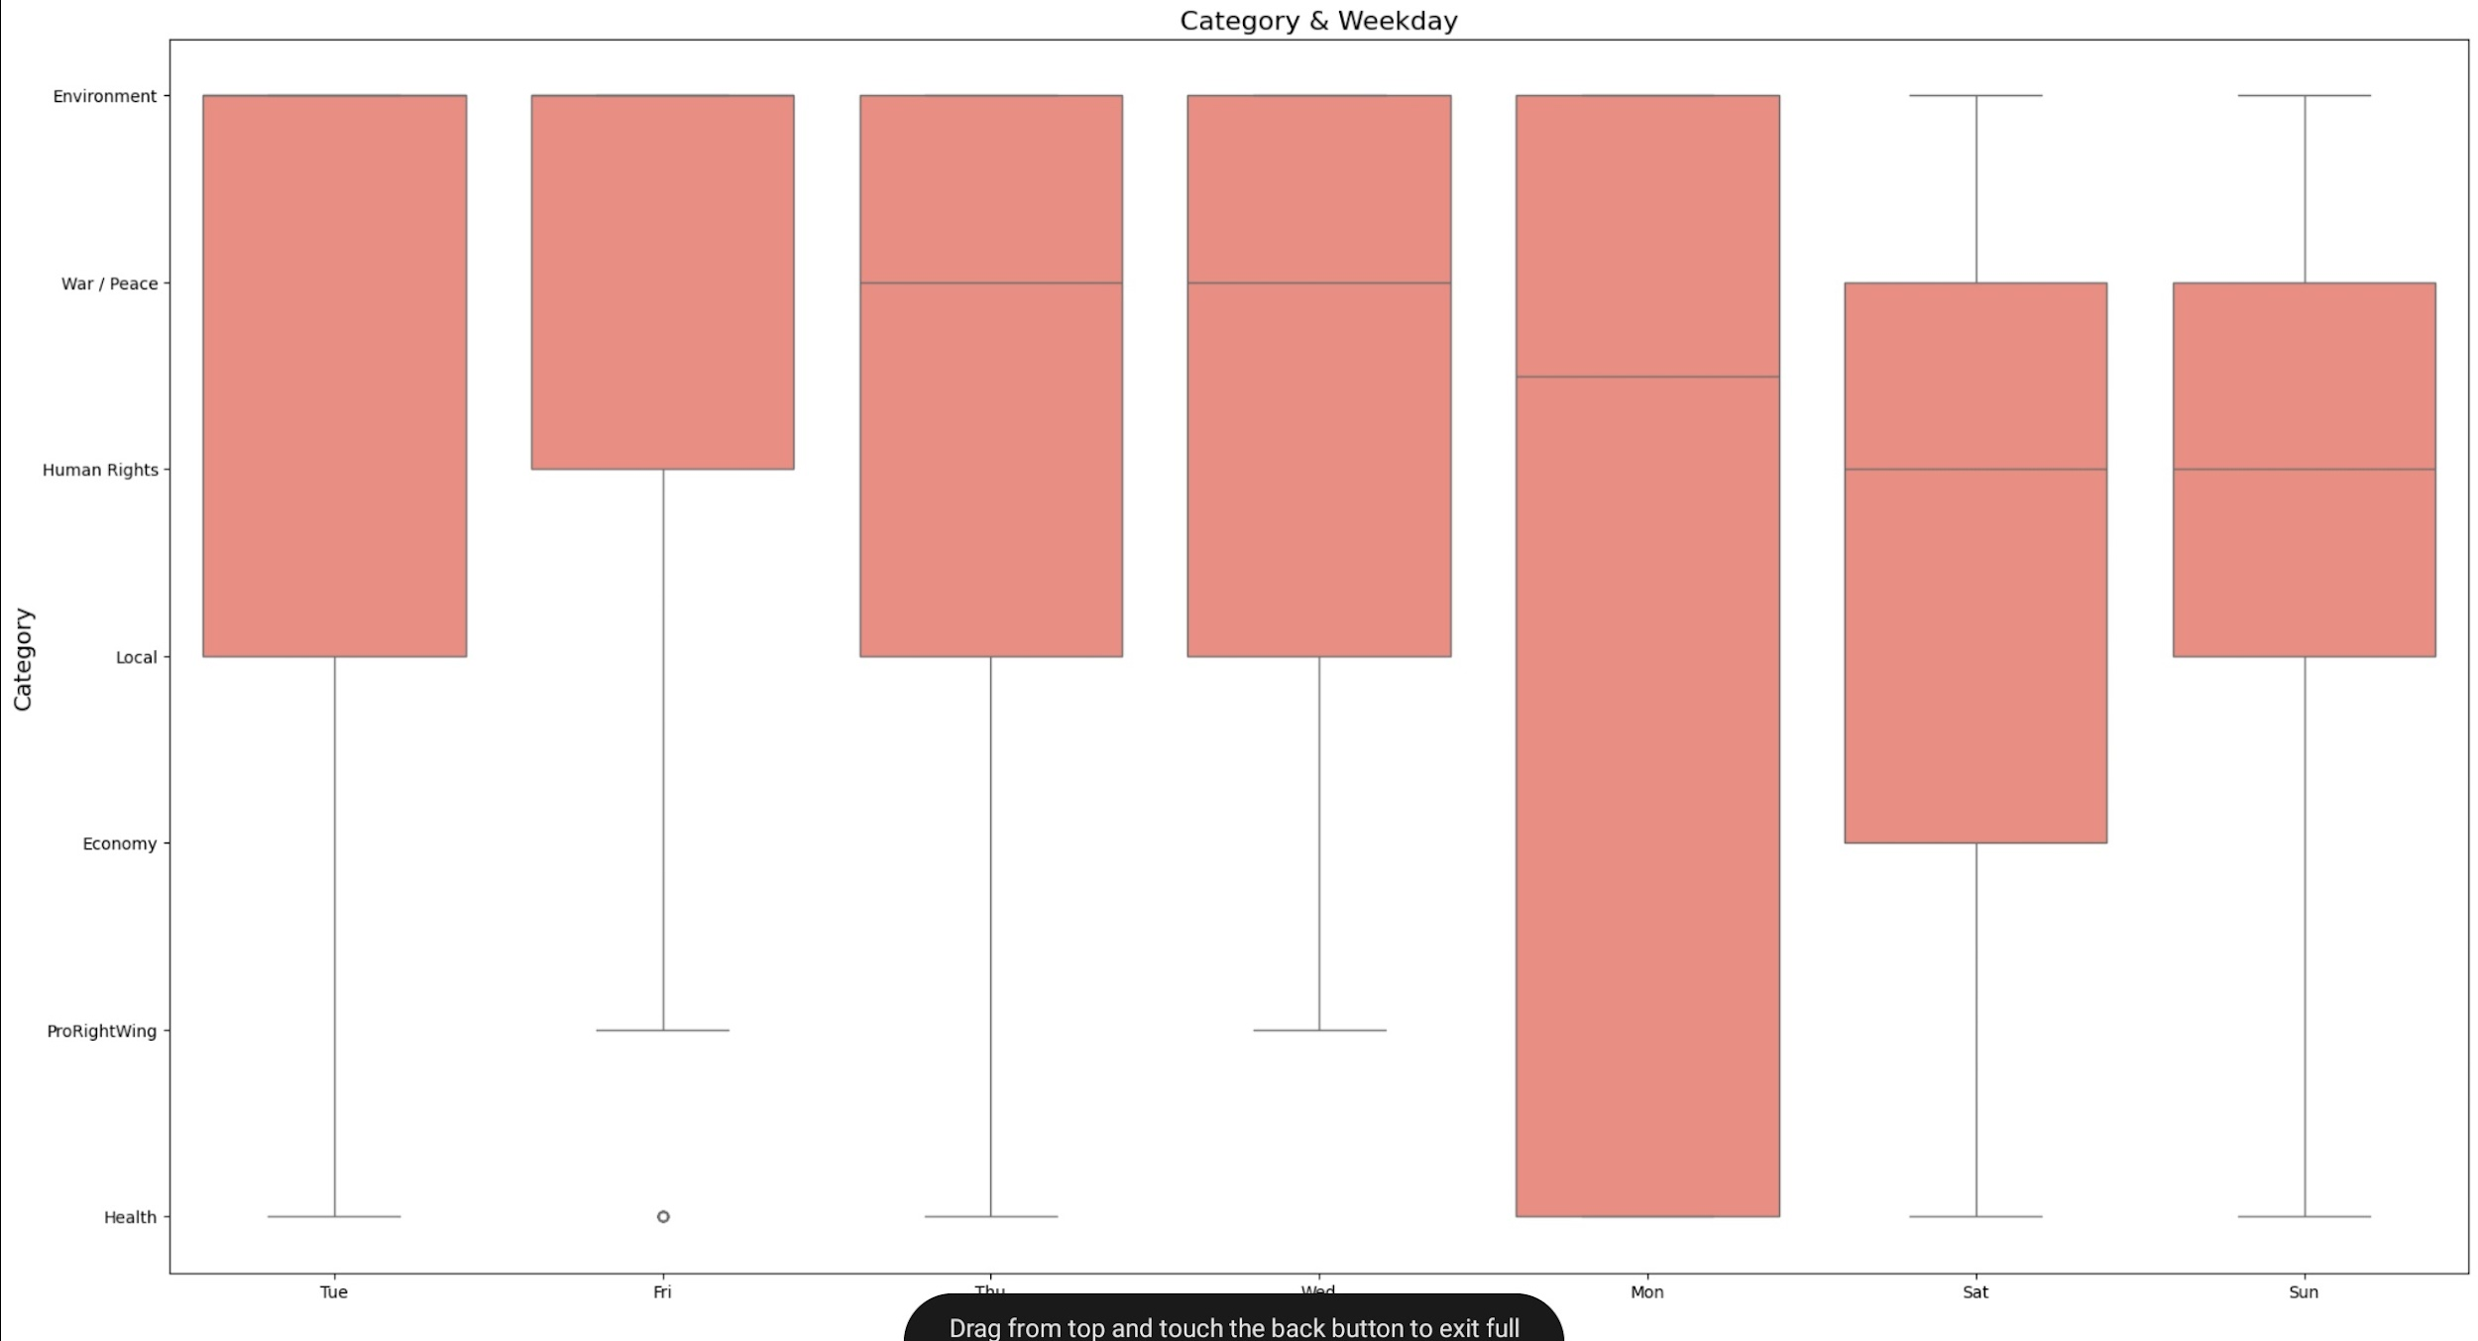

You can see Reinickendorf is a Hotspot for Coronavirus & ProRightwing, maybe because I labeled Querdenken as Far-Right?cs

